**REPORT**

**Title:** Speech to Text Recognition

**Members :**

**Team leader:** Bala Sriram Vankayala

**Reg number:** 11904495

**Roll number:** 29

**Member:** Sai Srujan Vemula

**Reg number :**11904349

**Roll number:** 12

**Faculty :** Sagar Pande

**Data of submission:** 4th November ,2020

**Abstract/summary:**

Are you surprised about how the modern devices that are non-living things listen your voice, not only this but they responds too. Yes, its looks like a fantasy, but now-a-days technology are doing the surprising things that were not possible in past. So guys, welcome to my new tutorial **Speech Recognition Python**.This is a very awesome and having lots of interesting stuffs. In this projectl we will learn about concept of speech recognition and it’s implementation in python.

**Contents:**

To understand the speech recgnoisition and its fundamentals . its working and applications in different areas its implementation in different areas its implementation . As the technologies are growing more rapidly and new features are emerging in this way speech recognition is one of them. Speech recognition is a technology that have evolved exponentially over the past few years. Speech recognition is one of the popular and best feature in computer world.

**Introduction:**

* Speech Recognition is a process in which a computer or device record the speech of humans and convert it into text format.
* It is also known as **Automatic Speech Recognition**(**ASR**), **computer speech recognition** or **Speech To Text** (**STT**).
* Linguistics, computer science, and electrical engineering are some fields that are associated with Speech Recognition.

It is based on the algorithm of  **acoustic** and **language modeling.**So now the question is -what is acoustic and language modeling?

* **Acoustic modeling** represents the relationship between linguistic units of speech and audio signals.
* **Language modeling** matches sounds with word sequences to help distinguish between words that sound similar.

**Any speech recognition program is evaluated using two factors:**

* **Accuracy** (percentage error in converting spoken words to digital data).
* **Speed** (extent to which the program can keep up with a human speaker).

### **applications:**

The most frequent applications of speech recognition are following:

* In-car systems.
* Health care – Medical documentation and Therapeutic use
* Military – High performance fighter aircraft ,Helicopters,Training air traffic controllers.
* Telephony and other domains
* Usage in Education and Daily life
* People with disabilities.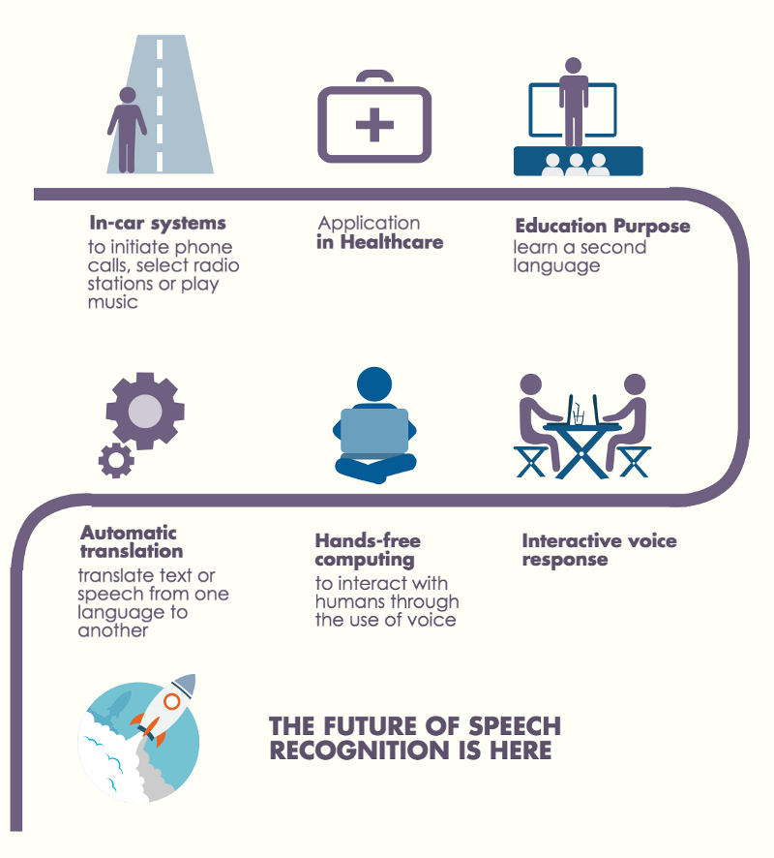

### Installing Libraries

we have to install two library for implementing speech recognition.

* [SpeechRecognition](https://pypi.org/project/SpeechRecognition/)
* [PyAudio](https://pypi.org/project/PyAudio/)

#### Installing SpeechRecognition

|  |  |  |
| --- | --- | --- |
| 1  2  3 | pip install SpeechRecognition |  |

SpeechRecognition is a library that helps in performing speech  recognition in python. It support for several engines and APIs, online and offline e.g. Google Cloud Speech API, Microsoft Bing Voice Recognition, IBM Speech to Text etc.

#### Installing PyAudio

|  |  |
| --- | --- |
| 1  2  3 | pip install pyaudio |

PyAudio provides [Python](http://www.python.org/) bindings for [PortAudio](http://www.portaudio.com/), the cross-platform audio I/O library. With PyAudio, you can easily use Python to play and record audio on a variety of platforms, such as GNU/Linux, Microsoft Windows, and Apple Mac OS X / macOS.

**CONCLUSION:**

The project is speech recgnoisistion started with a brief introduction of technology and its applictions in different sectors

***Thank you***